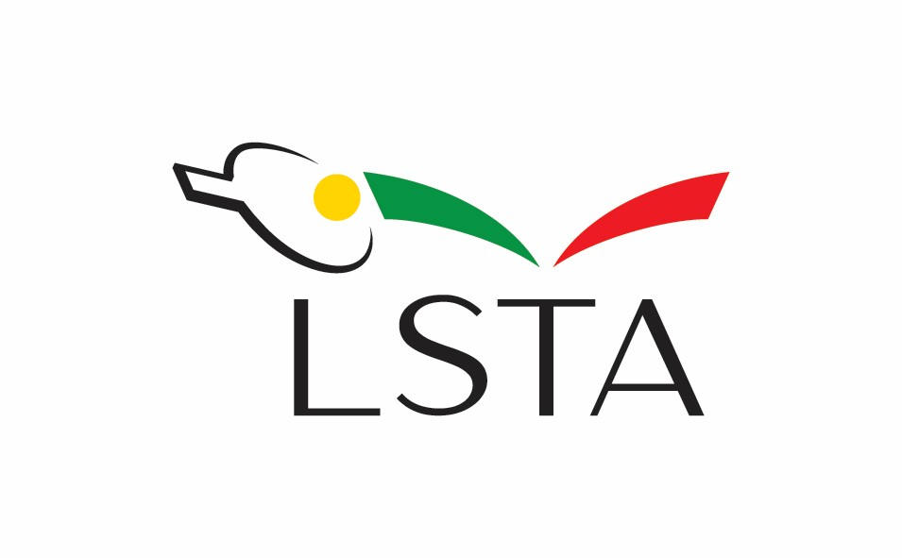
BALTIC STATES TABLE TENNIS CHAMPIONSHIPS 2023
REGULATIONS

1. Authority
Lithuanian Table Tennis Association, under the authority granted by the Baltic Table Tennis Union, will organize Baltic States Table Tennis Championships 2023.

2. Date and Place
The Championships will be held in Vilnius on September 9-10, 2023, in the sport School “Sostinės tauras” (Žygio str. 46, Vilnius, Lithuania).

3. Program of the Competitions
3.1. Team events (closed competitions only for Estonian, Latvian and Lithuanian national teams).
Men’s or women’s teams shall be the best of 5 singles. Team can consist of 5 players but in one match can take part only 3 players. The order of play shall be: A-X, B-Y, C-Z, A-Y and B-X. The match shall end when a team has won 3 individual matches. Team events will be played in round system. All individual matches in team events will be the best of 5 games.

3.2 Individual events
Men’s Singles and Women’s Singles will be played in groups of 4-5 players (round Robin system). In groups matches will be the best of 5 games. The two highest placed players from groups will form the final group, which will be played in knockout system with determination of the 3rd place. In final group matches will be the best of 7 games.

4. Schedule
Saturday, 09.09.2023 11.50 Opening ceremony
12.00 Men’s and Women’s team events
Lithuania I – Lithuania II
Latvia – Estonia

14.00 Men’s and Women’s team events
Lithuania I – Latvia
Lithuania II – Estonia

16. 00 – 18.00 Lunch

18.00 Men’s and Women’s team events
Lithuania I – Estonia
Lithuania II – Latvia

20.00 – 21.00 Dinner

Sunday, 10.09.2023 10.00 Men’s and Women’s Singles
Group competitions
12.00 – 13:00 Lunch
13.00 Men’s and Women’s Singles
Final competitions

15.30 Closing of the competition. Awarding Ceremony
15.50 Dinner

5. Rules
The Championships will be played in accordance with the Laws of TT and the Regulations of International table tennis federation.

6. Equipment
The following equipment will be used:
Tables: Joola (blue)
Nets: Joola
Ball: Joola Prime *** (white)

7. Eligibility
Team championships will be open to teams and players nominated by Lithuanian Table Tennis Association, Table Tennis Federation of Latvia and Estonian Table Tennis Federation. TTF of Latvia and Estonian TTF have the right to nominate 1 Men’s and 1 Women’s teams (each consisting of 5 players) and up to 5 players in Men’s and Women’s singles events. Lithuanian TTA has the right to nominate 2 Men’s and 2 Women’s teams and up to 10 players in Men’s and Women’s singles events.

8. Submission of entries
Entries with the names of players (with dates of birth), coaches, umpires and additional persons requiring accommodation must be sent not later than 01.08.2023 by e-mail: info@stalotenisas.lt

9. Umpires
Qualified umpires of Lithuanian TTA and invited umpires from Latvia and Estonia (one from each country) will control all team matches.

10. Hospitality
Lithuanian Table Tennis Association will provide accomodation for 2 nights (from 8th evening until 10th September 2023) and meals from breakfast 09.09.2023 until dinner 10.09.2023 up to 3 men, 3 women players, 1 umpire and 2 coaches of TTF of Latvia and Estonian TTF and all expenses related with the organization of the championships.
Costs for additional players with accommodation an meals – 80.00 EUR (per person, per 2 days, including entry fee for individual event). Entry fee for individual event without accommodation – 20.00 EUR for all players who don‘t have free hospitality.
Accommodation of the participants will be in Green Vilnius hotel, Pilaitės pr. 20, Vilnius, Lithuania

Justė Mažeikienė
Secretary General
Tel./Fax +370 5 233 79 43
Mob. +370 618 12300
email: info@stalotenisas.lt
www.stalotenisas.lt

